Q1) Are the HTML tags and elements the same thing?

Ans:) HTML tags are used to hold the HTML element which content almost similar to each other.

Q2) What are tags and attributes in HTML?

Ans:) Tags:

=> A element which is written in angle bracket is called a tag.

Attributes:

=> HTML attributes provide additional information about HTML elements.

Q3) What are void elements in HTML? With Example.

Ans): An element which are only self-closing without any content.

For Ex,

=> <br> Tag

=> <input>

=> <img>

Q4) What are HTML Entities? With Example.

Ans:) html entities means some special symbol which is not on keyboard . For Example,

<p>& Copy; </p>

<p>& Trade; </p>

<p>& Alpha; </p>

<p>& Reg; </p>

Q5) What are different types of lists in HTML? With Example.

Ans:) There is 3 type of list

1. unorder list: It can be used for anything that does not require order for context.

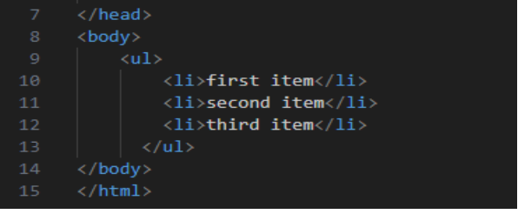

1. ordered list : It can be used for anything that required order for context.

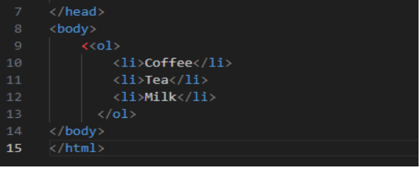

1. Description list : It describe the description of the particular things.

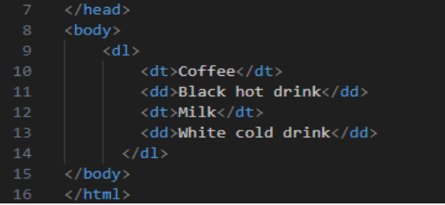

Q6) What is the ‘class’ attribute in HTML? With Example.

Ans:) The class attribute specifies one or more classnames for an element.

For example : class = "class".

Q7) What is the difference between the ‘id’ attribute and the ‘class’ attribute of HTML elements? With Example.

Ans:)

|  |  |
| --- | --- |
| ID Attributes | CLASS Attributes |
| The HTML id attribute is used to specify a unique id for an HTML element. | The class attribute specifies one or more classnames for an element. |
| The id attribute is used to point to a specific style declaration in a style sheet. | The class attribute is often used to point to a class name in a style sheet. It can also be used by a JavaScript to access and manipulate elements with the specific class name. |
| In the following example we have an <h1> element that points to the id name "myHeader". This <h1> element will be styled according to the #myHeader style definition in the head section: | In the following example we have three <div> elements with a class attribute with the value of "city". All of the three <div> elements will be styled equally according to the .city style definition in the head section: |

Q8) What are the various formatting tags in HTML?

Ans) There are ten types of lists in HTML such as :

•  **Bold Tag**

•  **Important Tag**

•  *Italic Tag*

• - Emphasized Tag

• - Marked Tag

• ~~- strike Tag~~

• - Smaller Tag

•

• - Inserted Tag

• -Subscript Tag

• - Superscript Tag

Q9) How is Cell Padding different from Cell Spacing? With Example.

Ans) Cellpading spacifies the space between the border of a table cell and it’s contents.

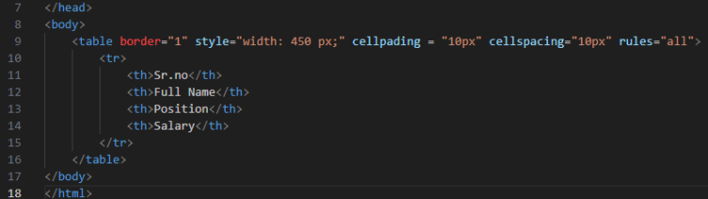

Q10) How can we club two or more rows or columns into a single row or column in an HTML table? With Example.

Ans) It can be done by using the rowspan and colspan attribute in HTML. The rowspan is used to merge or combine the number of cells in a row whereas the colspan is used to merge column cells in a table.

Q11) What is the difference between a block-level element and an inline element?

Ans:)

|  |  |
| --- | --- |
| Block Level Element | Inline Element |
| A block element begins on a new line. | It remains inline with all the text around the element and appears the same as inline. |
| Examples: div, p, li, main, etc. | It has no tag examples as it can be applied to any tag using CSS. |
| CSS property: display:block | CSS property: display:inline-block |

Q12) How to create a Hyperlink in HTML? With Example.

Ans:) The HTML tag defines a hyperlink. It has the following syntax:

<a href="*url*">*link text*</a>

Q13) What is the use of an iframe tag? With Example.

Ans:) An inline frame is used to embed another document within the current HTML document.

For example : <iframe src="01_marquee.html" frameborder="10px" width="400px" height="400px">

Q14) What is the use of a span tag? Explain with example?

Ans:) The span tag is a generic inline container element. You use this element to wrap sections of text for styling purposes or to add attributes to a section of text without creating a new line of content.

Q15) How to insert a picture into a background image of a web page? With Example.

Ans:) We can use the background attribute in the body tag to set an image as the background of the webpage. We will need to specify the URL or the location of the image which we want to set to the background attribute of the body tag.

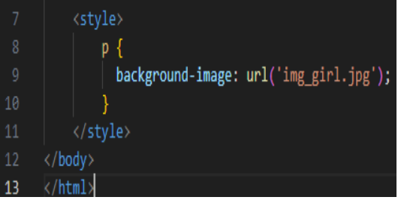

Q16) How are active links different from normal links?

Ans:) Active links are typically links that are currently functional and lead to live web pages, while normal links can refer to any link, whether functional or broken.

Q17) What are the different tags to separate sections of text?

Ans:) The different tags such as :

=> <br> tag - Usually <br> tag is used to separate the line of text. It breaks the current line and conveys the flow to the next line

=> <p> tag - The <p> tag contains the text in the form of a new paragraph.

=> <blockquote> tag - It is used to define a large quoted section. If you have a large quotation,

Q18) What is SVG?

Ans:) SVG stands for Scalable Vector Graphics

• SVG is used to define vector-based graphics for the Web

• SVG defines the graphics in XML format

• Every element and every attribute in SVG files can be animated.

Q19) What is difference between HTML and XHTML

Ans:)

|  |  |
| --- | --- |
| HTML | XHTML |
| HTML stands for Hypertext Markup Language | XHTML stands for Extensible Hypertext Markup Language. |
| HTML is a **markup language** itself. | XML provides a **framework to define markup languages**. |
| HTML is **not case sensitive**. | XML is **case sensitive**. |

Q20) What are logical and physical tags in HTML?

Ans:) Logical Tags are used in HTML to display the text according to the logical styles.

|  |  |
| --- | --- |
| Tag | Description |
| <abbr> | Defines an abbreviation |
| <address> | Defines an address element |
| <cite> | Defines citation |

Physical Tags:

Physical Tags are used in HTML to provide actual physical formatting to the text.

|  |  |
| --- | --- |
| Tag | Description |
| <b> | Defines bold text |
| <big> | Defines big text |
| <i> | Defines italic text |
| <small> | Defines small text |